Inventory

- odoo inventory is both an inventory application and a warehouse management system, with an advanced barcode scanner app.

- Learn how to manage lead times, automate replenishments, and configure advanced routes like drop-shipping, cross-docks, etc.

Replenishment

It can determine the efficiency of your flow of goods as they move throughts your supply chain

To create replenishment

Inventory -> Operations -> Replenishment -> Create

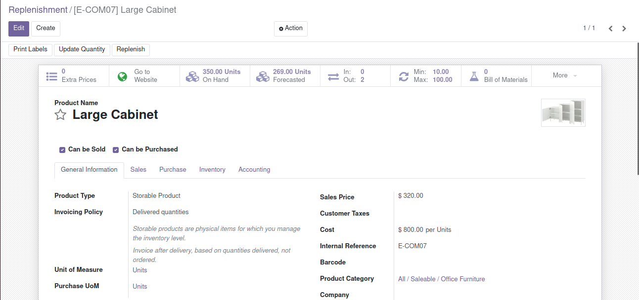

Scrap Management

- Scrap is the damaged, discarded or date expired products or materials that can be recycled.
- The Odoo system has a perfect scrap management system in its inventory module which will assist you to handle all the scrapped materials that are generated from the various phases of your inventory or business operations.
- Odoo manages and stores scraps in separate locations
- To create a scrap location in Odoo initially you should enable the Storage locations option from the settings menu of the Odoo Inventory module.

Inventory -> Configuration -> Settings -> Warehouse -> Storage Locations.
To create scrap
Inventory -> Operations -> Scrap -> Create

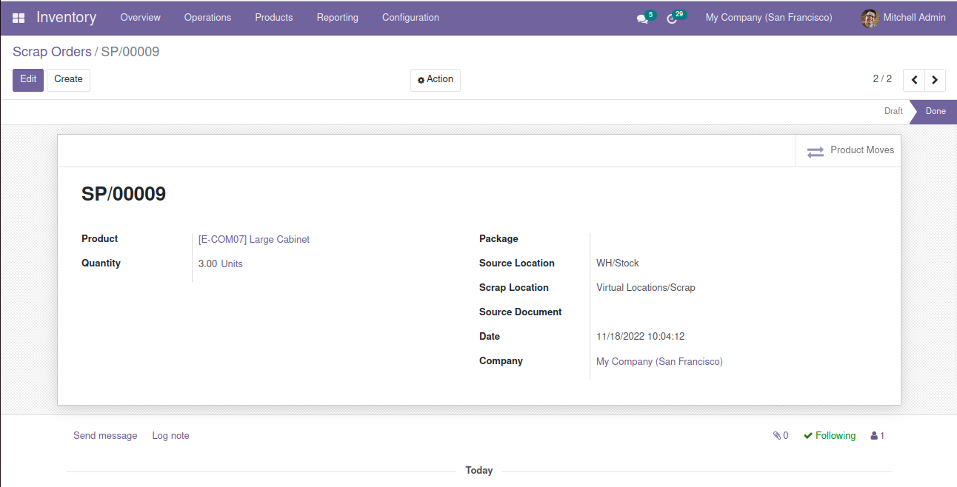

Landed Costs

- The landed cost of an item is the amount paid when the item is brought from the factory floor to the buyer’s door. This includes the price of the goods and the cost of shipping, insurance, customs duties, and any other charges incurred along the way.
- Landed cost calculation is not only crucial for business success; it is also a necessary part of it. By using the Odoo ERP system, one easily tracks your landed cost.

To create Landed Costs

Inventory -> Operations -> Landed Costs -> Create

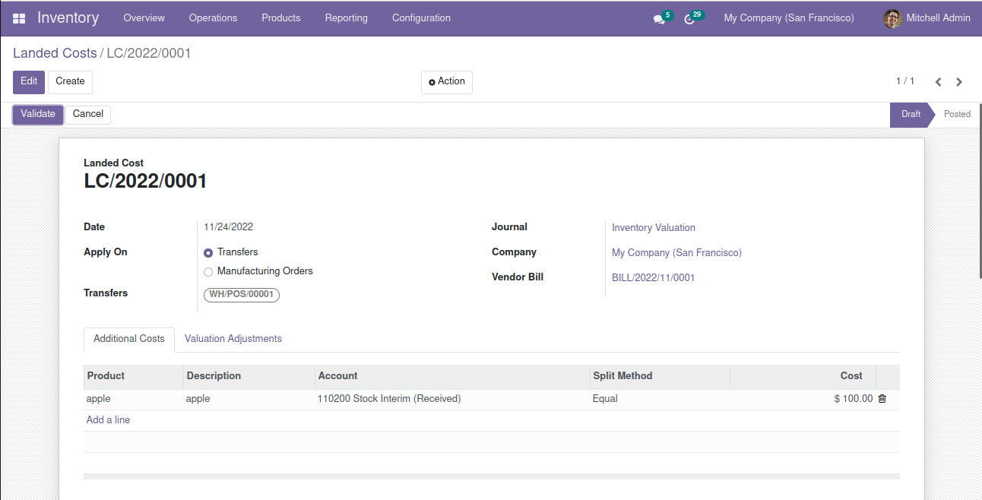

Warehouse Management
- The most important functionality of an Inventory management module is the warehouse management.
- warehouse constitutes the building or place where the stock items are stocked. In Odoo, one can easily set up multiple warehouses and create smooth and transparent moves between the warehouses. You can add any number of warehouses under your company.
To create Warehouse Management
Inventory -> Configuration -> Warehouse Management -> Warehouses -> Create
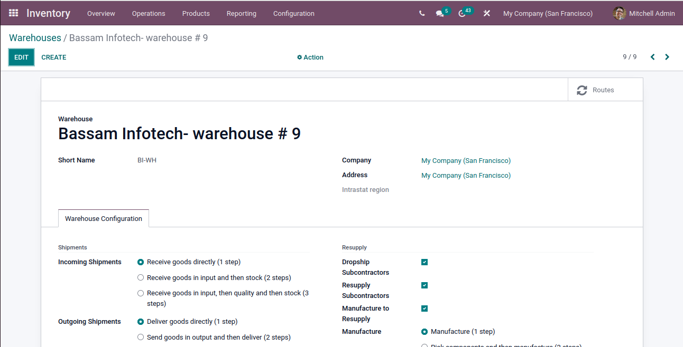
There are 3 types of location in warehouse:

- Physical Location: Where the loading and unloading take place eg:shelf
- Partner Location: This location not under your warehouse but space, within a customers or vendors warehouse.
- Virtual location: This is a virtual location which may not be physically available, but comes handy when you want to place the lost products out of your stock due to inventory loss or when you want to take into account the products that are on their way to your warehouse

